EXPERIMENT- 10

|  |  |
| --- | --- |
| Roll No.: B091 | Name: Yash Korla |
|  |  |
| Class: BTech Computer Engineering | Batch: B2 |
|  |  |
| Date of Experiment: 20-09-2023 | Date/Time of Submission: 24-09-2023 |
|  |  |
| Grade: |  |
|  |  |

**Aim:** Study of a CASE Tool

**Theory:**

**What is a CASE Tool?**

Computer-Aided Software Engineering (CASE) technologies are tools that provide automated assistance for software development. The goal of introducing CASE tools is the reduction of the time and cost of software development and the enhancement of the quality of the systems developed. The interest in CASE tools and environments is based on expectations about increasing productivity, improving product quality, facilitating maintenance, and making software engineers' task less odious and more enjoyable. CASE is the use of computer-based support in the software development process; a CASE tool is a computer-based product aimed at supporting one or more software engineering activities within a software development process; a CASE environment is a collection of CASE tools and other components together with an integration approach that supports most or all the interactions that occur among the environment components, and between the users of the environment and the environment itself.

**What is the significance of CASE Tools.**

When the term CASE is used, it is important to clarify what is being discussed. Most classifications of CASE tools start by considering whether the tool is upper CASE, lower CASE, or integrated CASE. An upper-case tool (front end CASE) provides support for the early stages in the systems development life cycle such as requirements analysis and design. A lower-case tool (back-end CASE) provides support for the later stages in the life cycle such as code generation and testing. Integrated CASE tools support both the early and later stages. Further classifications usually list which functionalities are supported by the tool, such as data flow diagrams, entity relationships data models, etc. provides a different type of model of CASE functionality which helps organize CASE tools. CASE Tools offer an

excellent array of features that support the development and business community through its Automated Diagram Support feature. The various popular features that aid the development community are listed below:

* Checks for syntactic correctness
* Data dictionary support
* Checks for consistency and completeness
* Navigation to linked diagrams
* Layering
* Requirements traceability
* Automatic report generation
* System simulation
* Performance analysis

CASE technology is the automation of step-by-step methodologies for software and system development. CASE tools are characterized by the stage or stages of software development life cycle on which they focus. Since different tools covering different stages share common information, it is required that they integrate through some central repository system (data dictionary) to have a consistent view of such information. In phases of software development life cycle integrated through a central data dictionary. Case Tools are used in many ways in our organizations. Case tools can be broadly classed into these broader areas:

* Requirement Analysis Tool
* Structure Analysis Tool
* Software Design Tool
* Code Generation Tool
* Test Case Generation Tool
* Document Production Tool
* Reverse Engineering Tool

**Different CASE Tools.**

There are many different types of CASE tools. They can be summarized as follows:

Diagramming tools

Report generators

Analysis tools

Documentation generators

Code generators

Repository of data

**Procedure:**

 1) Find out the various CASE tools and their usage.

 2) Compare and contrast the different CASE tools.

**Output:** Details of various CASE Tools and their functionalities

CASE (Computer-Aided Software Engineering) tools are software applications that assist in various stages of the software development lifecycle. They help automate and streamline tasks, improve collaboration among team members, and enhance the overall quality of software development projects. Here are details of various CASE tools and their functionalities:

1. **Diagramming Tools:**

   - Tool Examples**: Microsoft Visio, Lucidchart, draw.io

   - Functionality**: Diagramming tools help create visual representations of software components, workflows, and data structures. They are often used for creating flowcharts, UML diagrams, ER diagrams, and other types of diagrams to aid in design and documentation.

Certainly! There are many diagramming tools available for various purposes, from flowcharts and wireframes to technical diagrams and network diagrams. Here are some popular diagramming tools along with their details:

1. **Lucidchart:**

   - Lucidchart is a cloud-based diagramming tool that offers a wide range of templates for flowcharts, diagrams, and wireframes.

   - It supports real-time collaboration, making it a good choice for teams.

   - Integrates with popular applications like Google Workspace, Microsoft Office, and more.

Specialization: Collaborative diagramming tool with a wide range of templates, suitable for business processes, flowcharts, wireframes, and technical diagrams.

2. **Microsoft Visio:**

   - Visio is a diagramming tool from Microsoft that's widely used for creating flowcharts, organizational charts, network diagrams, and more.

   - It's available both as a standalone application and as part of the Microsoft 365 suite.

Specialization: Comprehensive diagramming software widely used for creating technical diagrams, flowcharts, network diagrams, and organizational charts.

3**. Draw.io (Diagrams.net):**

   - Draw.io, also known as Diagrams.net, is an open-source diagramming tool that can be used online or offline.

   - It offers a wide variety of diagram types, and you can integrate it with various cloud storage platforms.

Specialization: Open-source, versatile diagramming tool suitable for creating various diagram types, including flowcharts, network diagrams, and UML diagrams.

4. **OmniGraffle:**

   - OmniGraffle is a diagramming and graphic design tool available for macOS and iOS devices.

   - It's known for its powerful features for creating intricate diagrams and wireframes.

Specialization: Diagramming and graphic design tool for macOS and iOS, known for its capabilities in creating complex and visually appealing diagrams and wireframes.

5. **Creately:**

   - Creately is a web-based diagramming tool with a focus on collaboration.

   - It offers templates for flowcharts, mind maps, org charts, and more.

Specialization: Web-based collaborative diagramming tool suitable for flowcharts, mind maps, org charts, and other business diagrams.

6. **Gliffy:**

   - Gliffy is an online diagramming tool that's easy to use and integrates with popular collaboration tools like Confluence and Jira.

Specialization: Online diagramming tool with a focus on integration with collaboration tools like Confluence and Jira, suitable for flowcharts and diagrams.

7. **Cacoo:**

   - Cacoo is a cloud-based diagramming tool that emphasizes real-time collaboration and integration with various third-party apps.

   - It's suitable for creating flowcharts, wireframes, and network diagrams.

Specialization: Cloud-based real-time collaborative diagramming tool with integration options for various third-party applications, suitable for flowcharts and wireframes.

8. **PlantUML:**

   - PlantUML is a text-based diagramming tool that's ideal for creating UML diagrams, flowcharts, and other technical diagrams using plain text code.

Specialization: Text-based diagramming tool ideal for creating UML diagrams, flowcharts, and technical diagrams using plain text code.

9. **yEd Graph Editor:**

   - yEd is a free, cross-platform diagramming application with features for creating various types of diagrams, including flowcharts, network diagrams, and more.

Specialization: Cross-platform diagramming application with features for creating diverse types of diagrams, including flowcharts and network diagrams.

10. **Dia:**

    - Dia is an open-source diagramming tool that's similar in functionality to Microsoft Visio.

    - It's available for Windows, macOS, and Linux.

Specialization: Open-source alternative to Microsoft Visio, suitable for creating various diagrams such as flowcharts, network diagrams, and more.

11. **Pencil Project:**

    - Pencil Project is a free and open-source GUI prototyping and diagramming tool that's particularly useful for creating UI wireframes and mockups.

Specialization: Open-source GUI prototyping and diagramming tool, ideal for creating UI wireframes and mockups.

12. **Balsamiq Mockups:**

    - Balsamiq is a wireframing and mockup tool specifically designed for creating quick and rough sketches of user interfaces.

Specialization: Wireframing and mockup tool designed for quickly sketching user interface designs.

These diagramming tools vary in terms of features, pricing, and the types of diagrams they support. The choice of tool will depend on your specific needs and preferences. Many of them offer free trials or free versions with limited features, so you can explore and choose the one that best suits your requirements.

Compare and contrast the different CASE tools.

**Procedure:**

 1) Find out the various CASE tools and their usage.

 2) Compare and contrast the different CASE tools.

**Output:** Details of various CASE Tools and their functionalities

CASE (Computer-Aided Software Engineering) tools are software applications that assist in various stages of the software development lifecycle. They help automate and streamline tasks, improve collaboration among team members, and enhance the overall quality of software development projects. Here are details of various CASE tools and their functionalities:

1. **Diagramming Tools:**

   - Tool Examples**: Microsoft Visio, Lucidchart, draw.io

   - Functionality**: Diagramming tools help create visual representations of software components, workflows, and data structures. They are often used for creating flowcharts, UML diagrams, ER diagrams, and other types of diagrams to aid in design and documentation.

Certainly! There are many diagramming tools available for various purposes, from flowcharts and wireframes to technical diagrams and network diagrams. Here are some popular diagramming tools along with their details:

1. **Lucidchart:**

   - Lucidchart is a cloud-based diagramming tool that offers a wide range of templates for flowcharts, diagrams, and wireframes.

   - It supports real-time collaboration, making it a good choice for teams.

   - Integrates with popular applications like Google Workspace, Microsoft Office, and more.

Specialization: Collaborative diagramming tool with a wide range of templates, suitable for business processes, flowcharts, wireframes, and technical diagrams.

2. **Microsoft Visio:**

   - Visio is a diagramming tool from Microsoft that's widely used for creating flowcharts, organizational charts, network diagrams, and more.

   - It's available both as a standalone application and as part of the Microsoft 365 suite.

Specialization: Comprehensive diagramming software widely used for creating technical diagrams, flowcharts, network diagrams, and organizational charts.

3**. Draw.io (Diagrams.net):**

   - Draw.io, also known as Diagrams.net, is an open-source diagramming tool that can be used online or offline.

   - It offers a wide variety of diagram types, and you can integrate it with various cloud storage platforms.

Specialization: Open-source, versatile diagramming tool suitable for creating various diagram types, including flowcharts, network diagrams, and UML diagrams.

4. **OmniGraffle:**

   - OmniGraffle is a diagramming and graphic design tool available for macOS and iOS devices.

   - It's known for its powerful features for creating intricate diagrams and wireframes.

Specialization: Diagramming and graphic design tool for macOS and iOS, known for its capabilities in creating complex and visually appealing diagrams and wireframes.

5. **Creately:**

   - Creately is a web-based diagramming tool with a focus on collaboration.

   - It offers templates for flowcharts, mind maps, org charts, and more.

Specialization: Web-based collaborative diagramming tool suitable for flowcharts, mind maps, org charts, and other business diagrams.

6. **Gliffy:**

   - Gliffy is an online diagramming tool that's easy to use and integrates with popular collaboration tools like Confluence and Jira.

Specialization: Online diagramming tool with a focus on integration with collaboration tools like Confluence and Jira, suitable for flowcharts and diagrams.

7. **Cacoo:**

   - Cacoo is a cloud-based diagramming tool that emphasizes real-time collaboration and integration with various third-party apps.

   - It's suitable for creating flowcharts, wireframes, and network diagrams.

Specialization: Cloud-based real-time collaborative diagramming tool with integration options for various third-party applications, suitable for flowcharts and wireframes.

8. **PlantUML:**

   - PlantUML is a text-based diagramming tool that's ideal for creating UML diagrams, flowcharts, and other technical diagrams using plain text code.

Specialization: Text-based diagramming tool ideal for creating UML diagrams, flowcharts, and technical diagrams using plain text code.

9. **yEd Graph Editor:**

   - yEd is a free, cross-platform diagramming application with features for creating various types of diagrams, including flowcharts, network diagrams, and more.

Specialization: Cross-platform diagramming application with features for creating diverse types of diagrams, including flowcharts and network diagrams.

10. **Dia:**

    - Dia is an open-source diagramming tool that's similar in functionality to Microsoft Visio.

    - It's available for Windows, macOS, and Linux.

Specialization: Open-source alternative to Microsoft Visio, suitable for creating various diagrams such as flowcharts, network diagrams, and more.

11. **Pencil Project:**

    - Pencil Project is a free and open-source GUI prototyping and diagramming tool that's particularly useful for creating UI wireframes and mockups.

Specialization: Open-source GUI prototyping and diagramming tool, ideal for creating UI wireframes and mockups.

12. **Balsamiq Mockups:**

    - Balsamiq is a wireframing and mockup tool specifically designed for creating quick and rough sketches of user interfaces.

Specialization: Wireframing and mockup tool designed for quickly sketching user interface designs.

These diagramming tools vary in terms of features, pricing, and the types of diagrams they support. The choice of tool will depend on your specific needs and preferences. Many of them offer free trials or free versions with limited features, so you can explore and choose the one that best suits your requirements.

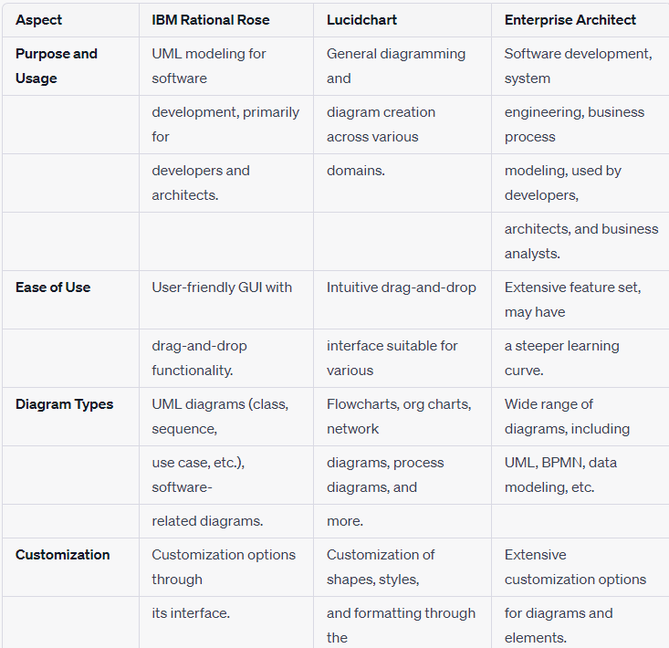

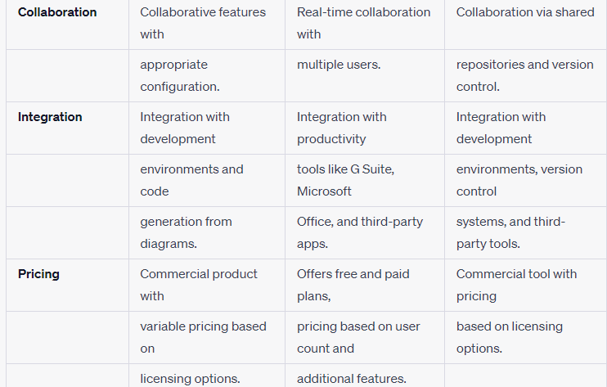

* Conclusion: Hereby we have Studied the CASE Tool